A: TO INSTALL AN IMPORT SPECIFICATION
(note an import specification is not included in a ‘structure file’ and the method to load a import specification is different from doing a structure update.)

SCREEN A1
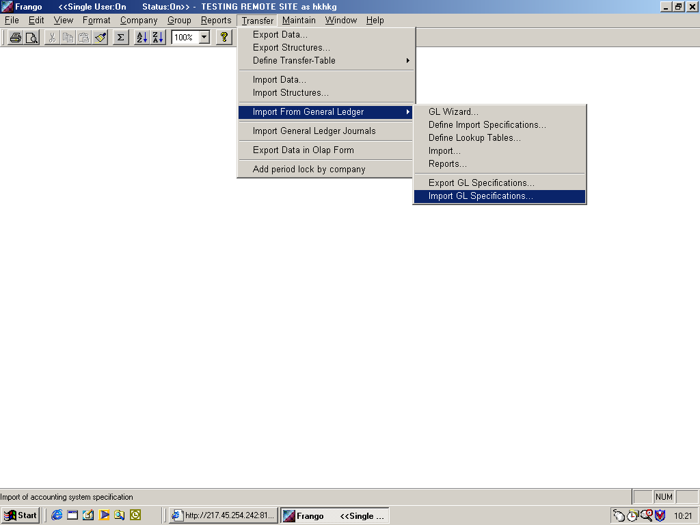

SCREEN A2
Select import specification file (this will end with .fzg)
This you will select from the location to which you have saved the .fzg file
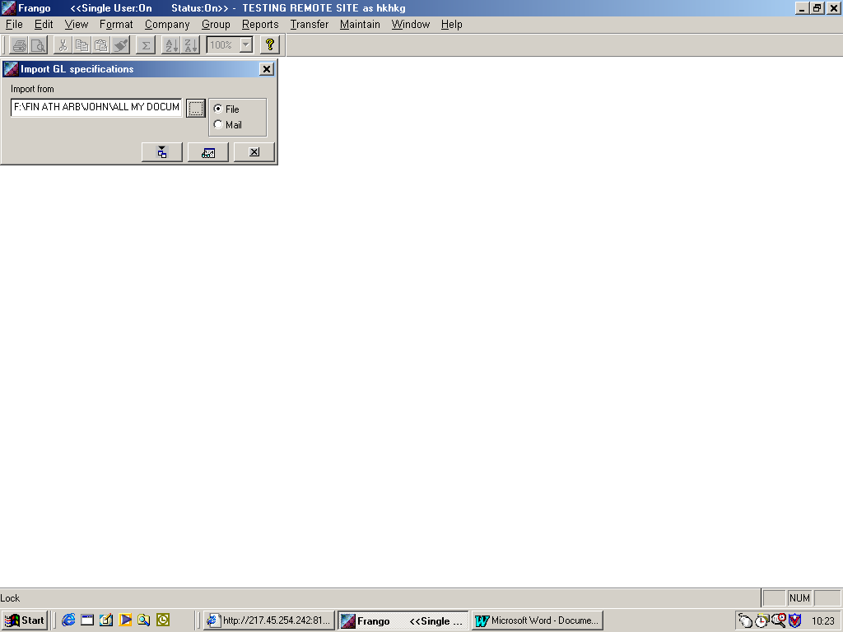

B: TO IMPORT .CSV FILE
(name format 0301ABCDEac.csv , where 0301 = year 2003 period 1)

SCREEN B1

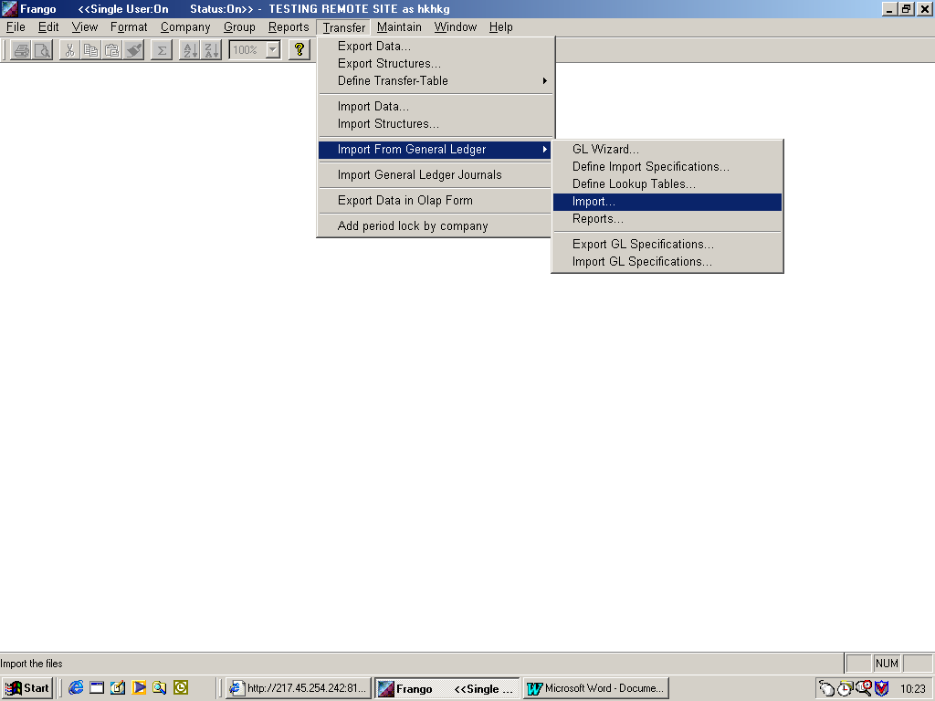
SCREEN B2
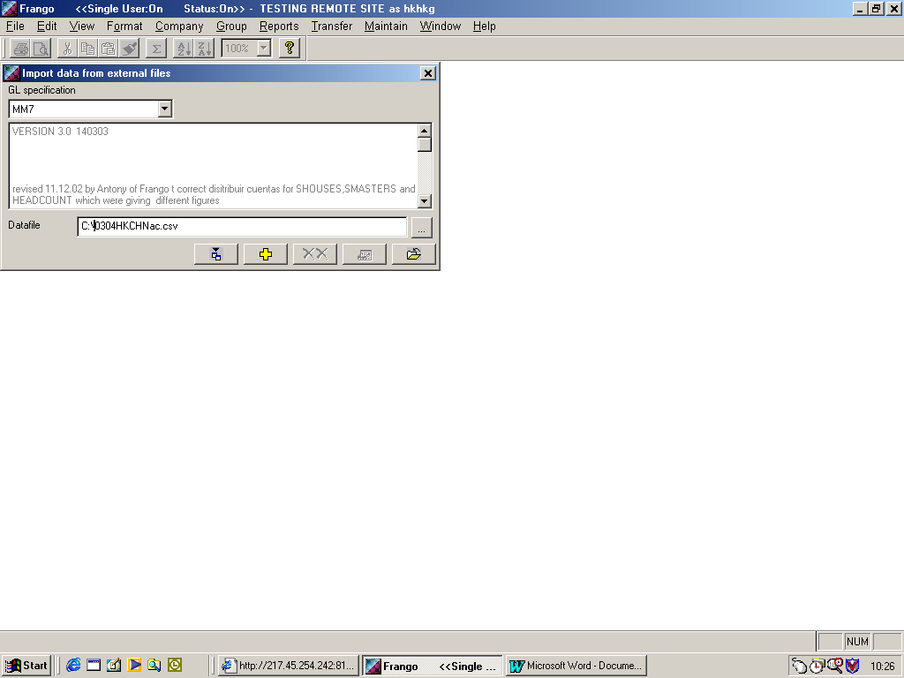
SCREEN B3
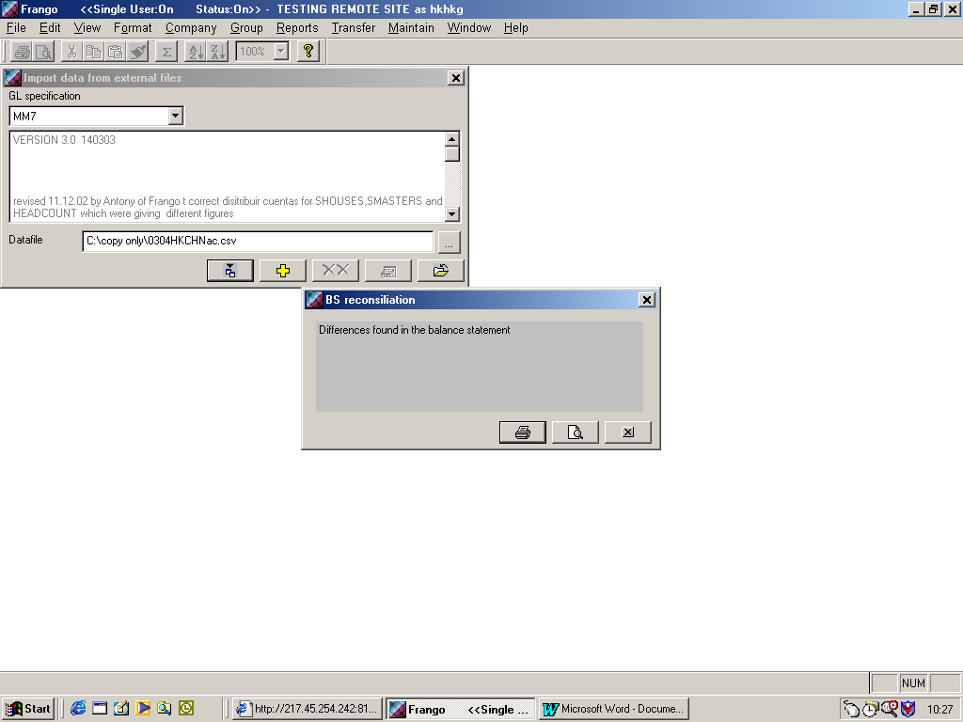
Once imported you will see message “difference found in the balance sheet”, which is due to round of all amounts that have been imported.

By selecting the ‘report to screen’ icon and you will see below.
SCREEN B4
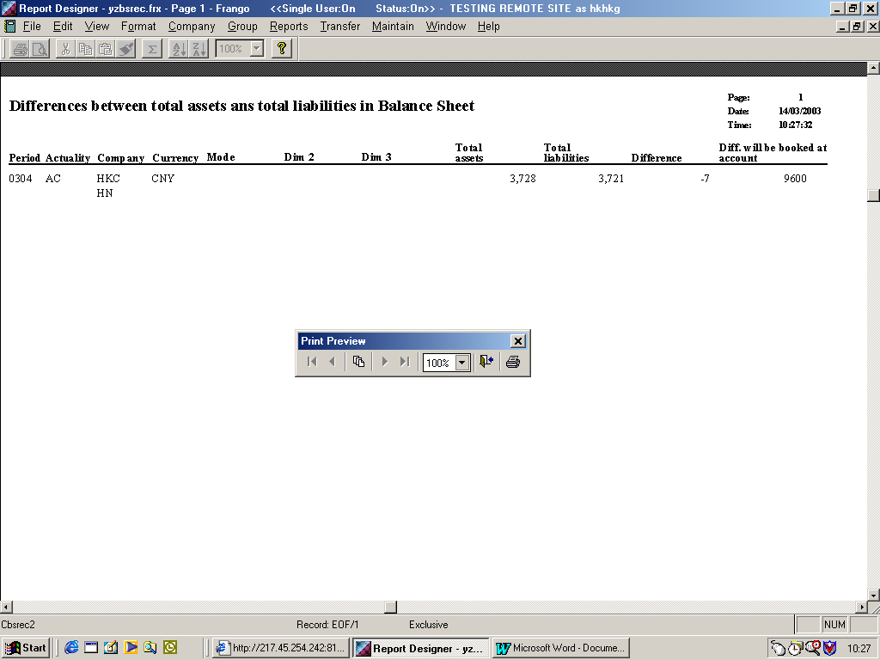
Differences are loaded to Frango account code 9600 in input forms. The amount should be less than 10 and need to be adjusted manully before sending to Frango@jasww.com the Fzd file for the period.

SCREEN B5
When preview is closed the following screen appears
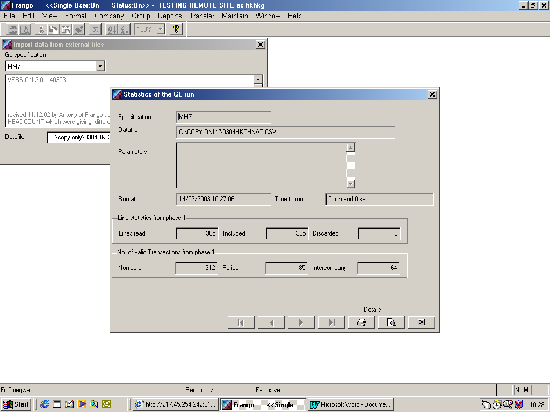

SCREEN B6
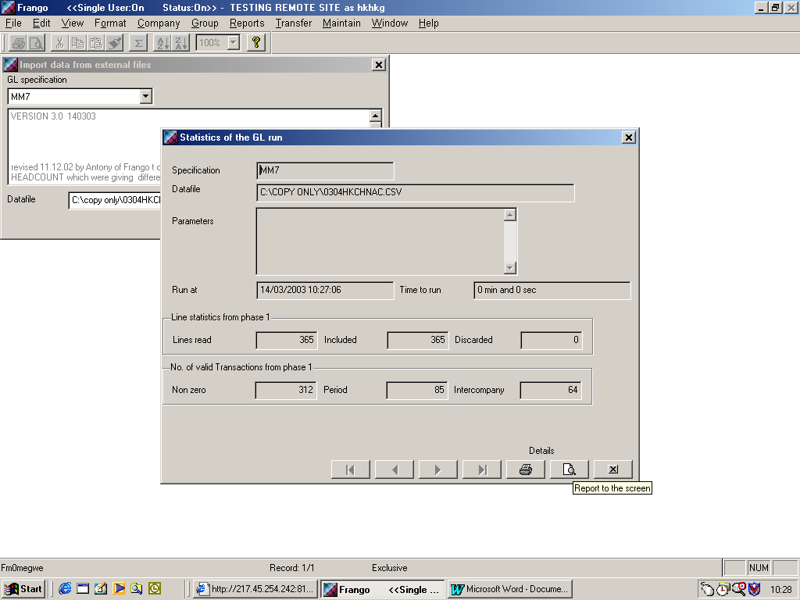

SCREEN B7
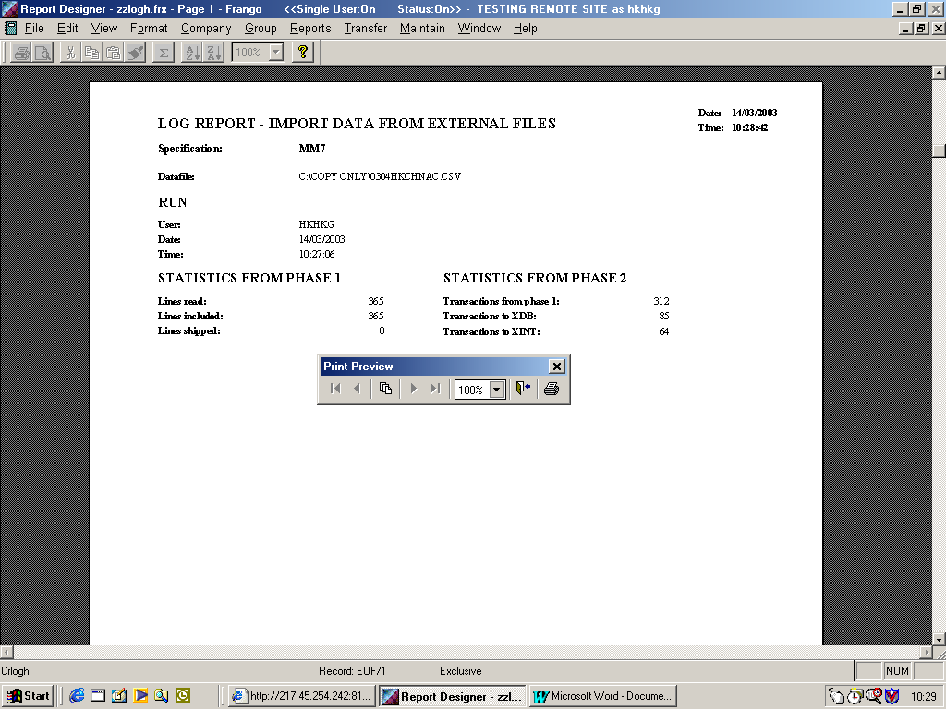

SCREEN B8

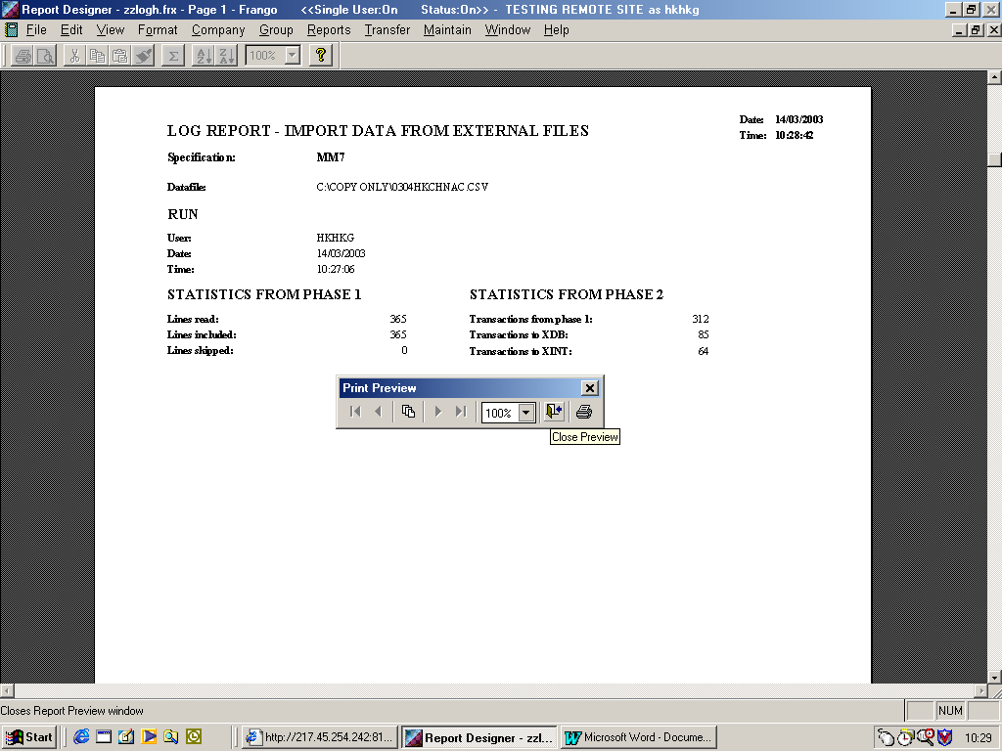

SCREEN B9
On period 0301,0302,0304,0305,0307,0308,0310,0311 you will see “transaction ignored due to invalid account (not 03XX in valid form connected to the period)”
The Accounts shown should only be I3040 and I4040 as input forms 321Q and 322Q are not part of form set for these period.

IMPORTANT:
IF YOU HAVE ANY OTHER CODE SHOWN PLEASE CONTACT JASWWFS WITH FULL DETAILS

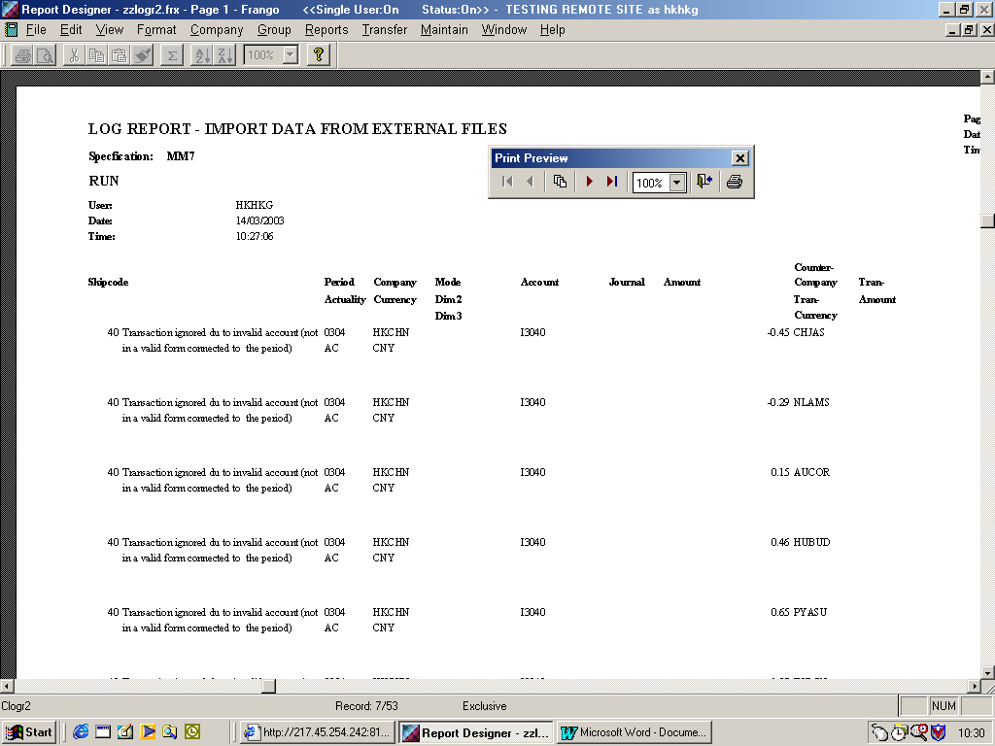

SCREEN B9

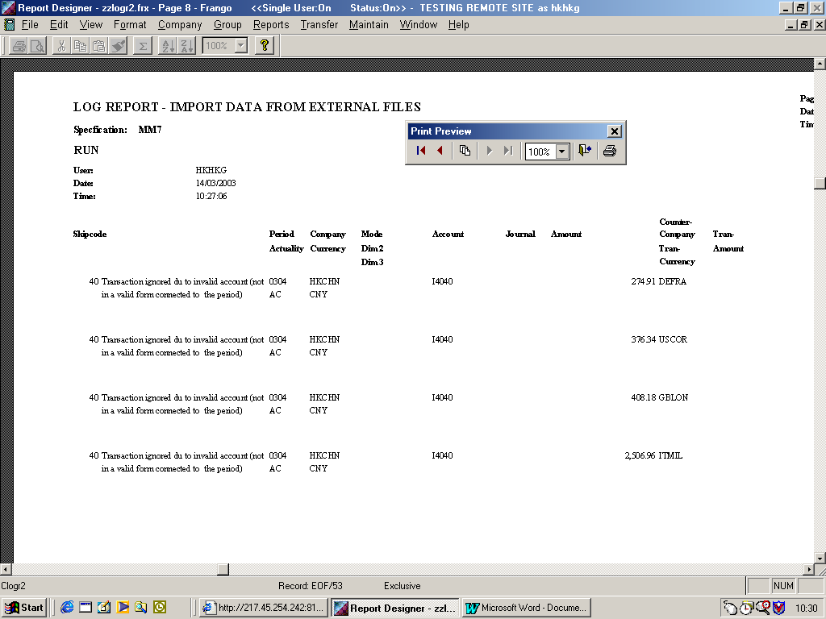

C: IMPORTING .CSV for periods 0213,0303,0306,0309,0312,0313

SCREEN C1
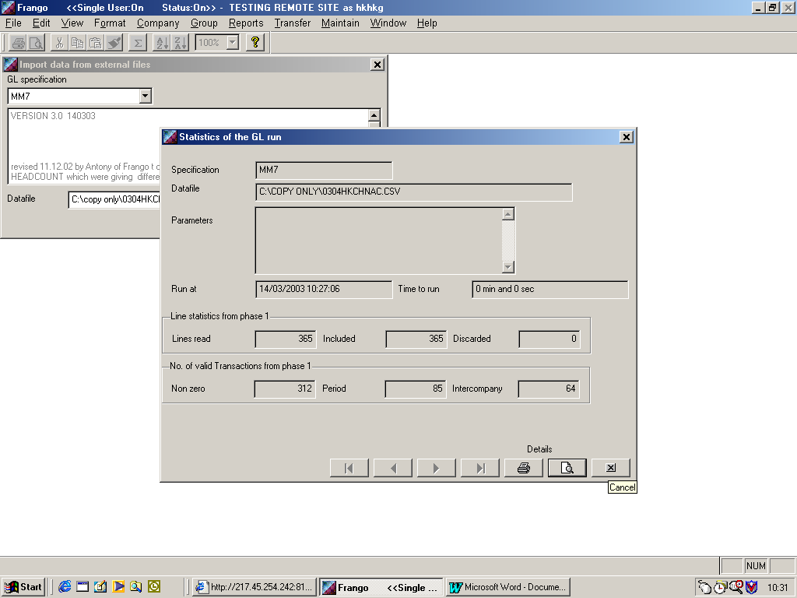

ON IMPORT OF PERIOD 0303,0306,0309,0312,0313

SCREEN C2
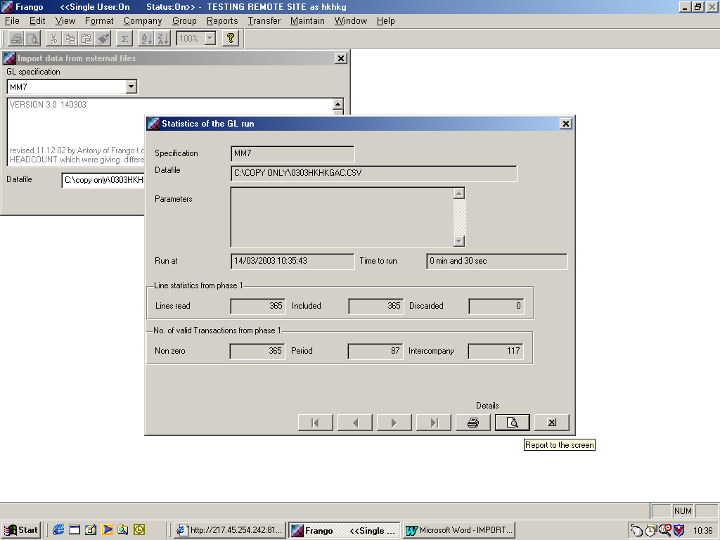

SCREEN C3
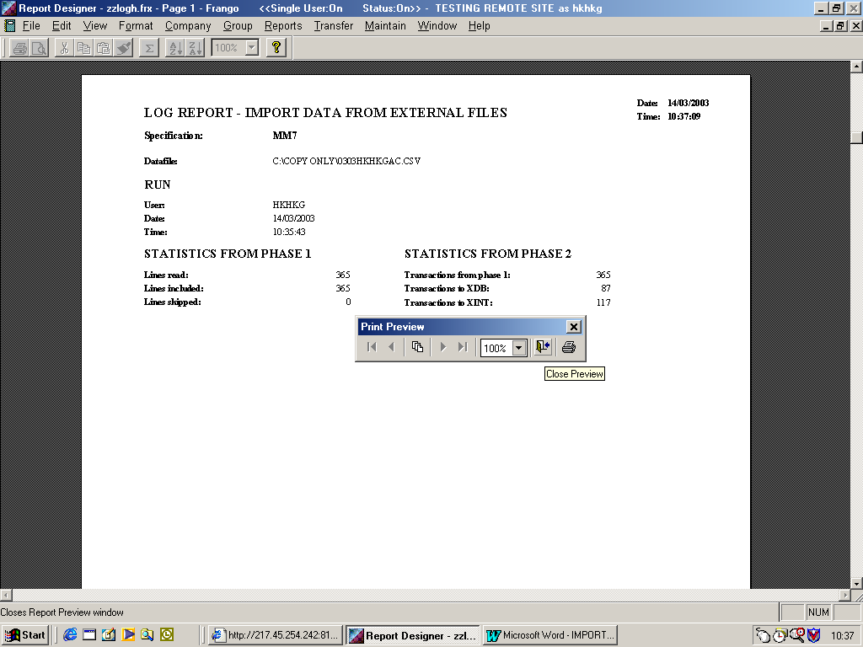

SCREEN C4

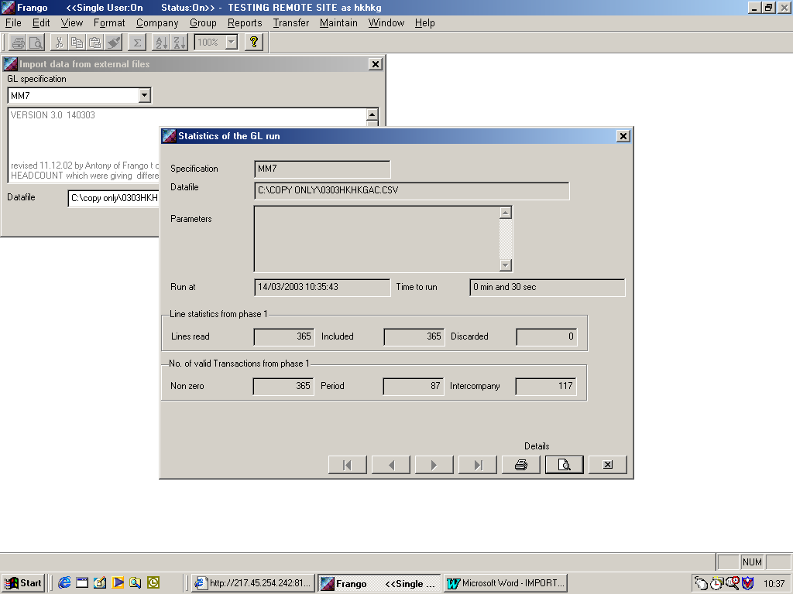

SCREEN C5
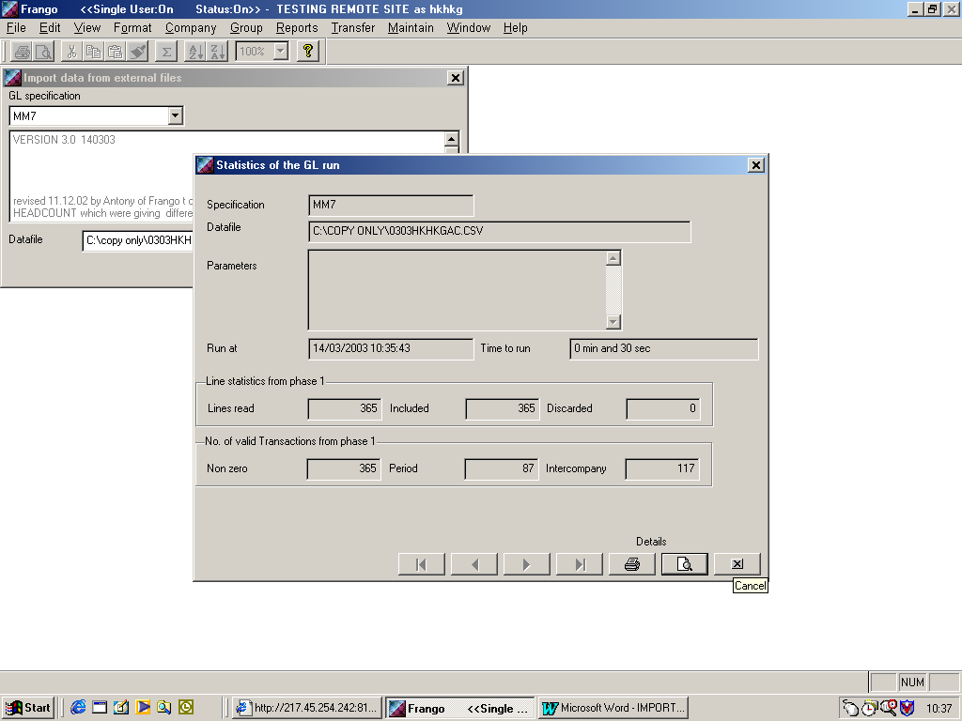

IMPORTANT :

YOU SHOULD NOT SEE ANY OTHER SCREENS , WHEN YOU IMPORT CSV FOR PERIODS 0212,0213,0303,0306,0309,0312,0313

IF YOU OBTAIN SCREEN SIMILAR TO SCREEN B8 OR SCREEN B9 SHOWING ANY ACCOUNTS NOT IMPORTED YOU MUST CONTACT JASWWFS

